THE 4TH INTERNATIONAL SCIENTIFIC ALEKSANDRAS VANAGAS' CONFERENCE

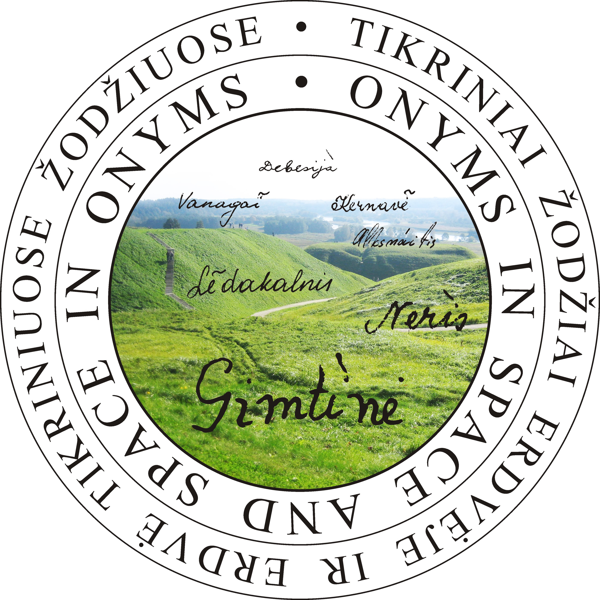
Onyms in Space and Space in Onyms

7–9 November 2019,
The Institute of the Lithuanian Language, Vilnius, Lithuania

ABSTRACT

Title

. . . . . . . . . . . . . . . . . . . . . . . . . . . . . . . . . . .

[1500-2500 characters.
Font 12 Times New Roman]

Abstracts should be sent to avk@lki.lt by 3 June 2019.

